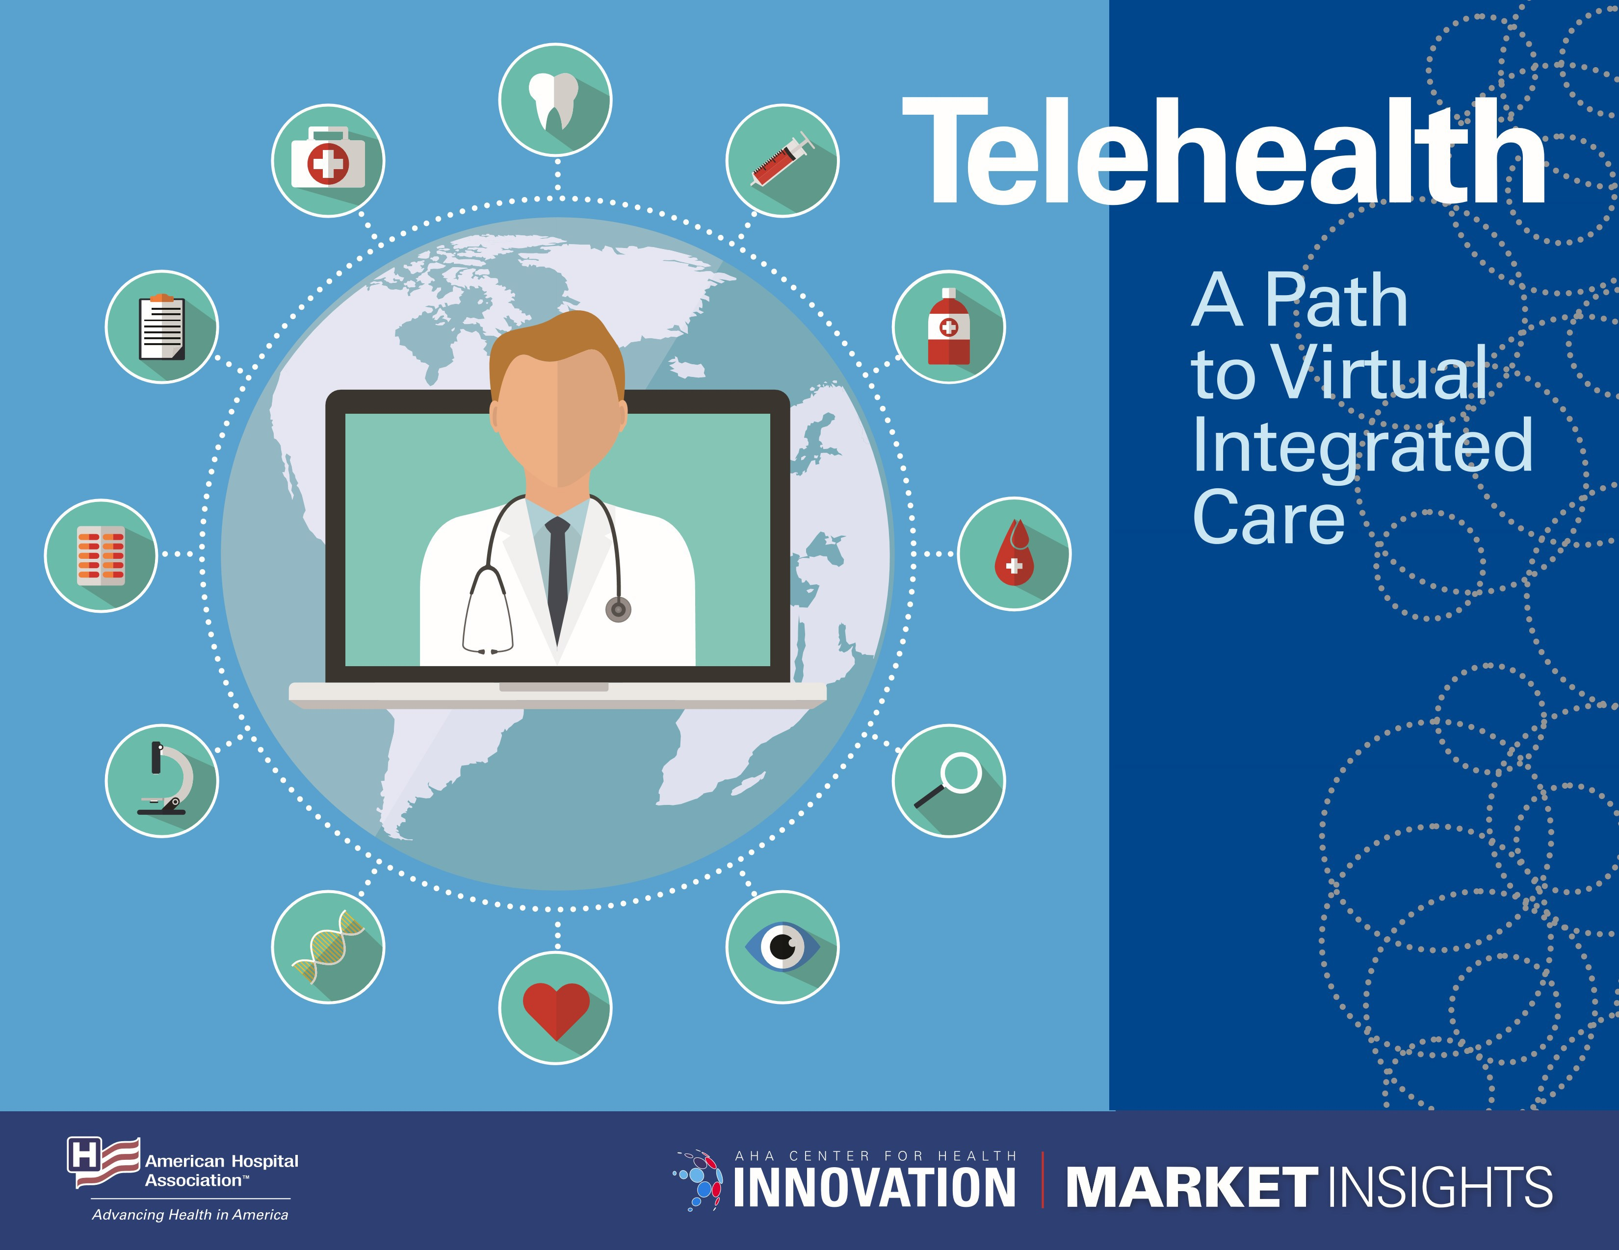

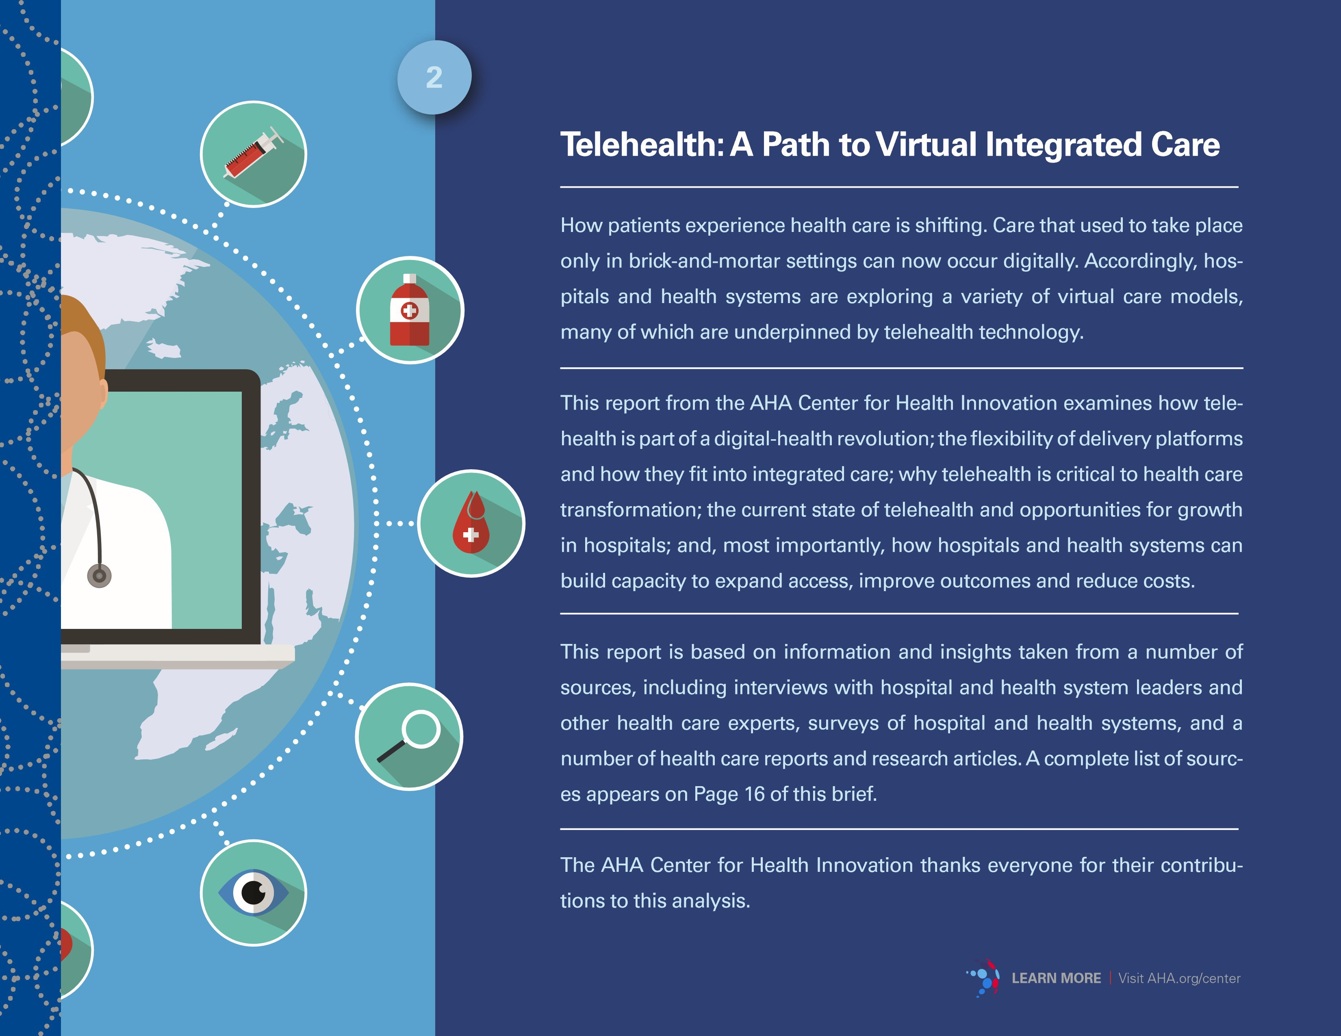

@
97°/o
Patients satisfied

bile devices and faster internet connections have provided new ways for patients and providers to interact. Patients are increasingly making decisions about who delivers their care and engaging in the deliver y of that care digitally As a result, hospitals and health systems need a strategy for their own digital transformation.
Telehealth's Role in DigitalTransformation

Telehealth is part of a larger digital transformation in health care. The electronic health record (EHR), omnipresent mo­

with their first telehealth expe­ rience and would recommend the program
Source: Harvard Business Review

1 million
Americans are using remote cardiac monitors
Source: American Tele­ medicine Association

Hospitals already are using telehealth to improve access and fill gaps in care; provide services 24/7; and expand access to medical specialists. It's a smart way to leverage finite health care resources as demands for health care services increase.

Telehealth and digital health care enable a model of care that is ubiq­ uitous and seamless, more affordable and integrated into patients' lives. In the shift to demand-driven health care, telehealth becomes the patient's first -and most frequent - point of access for urgent care, triage for emergent conditions, specialty consults, post-dis­ charge management, medication education, behavioral health coun­ seling, chronic care management and more.

Hospitals and health systems that are working now to increase the maturity of their telehealth capabilities will be well-positioned to meet patient demands for digital tools that allow them to conve­ niently engage in care. Hospitals that don't address these expec­ tations increasingly will be challenged by new market entrants and other disruptors that seek to attract new health care consumers and encroach on existing patient-provider relationships.

DefiningTelehealth Delivery Platfonns: Provider to Provider and Direct to Consumer
Today, hospitals and health systems offer several types of telehealth services to improve access to services and quality of care. Tele­ health delivery platforms fall into two main categories:

Provider-to-provider, which extends expertise and resourc­ es for specialty and subspecialty care, and addresses work­
II
force shortages and the efficient use of health professionals.
R Direct-to-consumer, which includes virtual care, remote patient
lllil monitoring and extending care delivery into the home via technology.
The Health Resources & Services Administration of the Department of Health & Human Services defines telehealth as the use of electronic in­ formation and telecommunication technologies to support and promote long-distance clinical health care, patient and professional health-related education, public health and health administration. The most common telehealth platforms include synchronous and asynchronous technol­ ogies like videoconferencing, store-and-for ward imaging, email and remote-patient monitoring .

9 Areas inWhich Telehealth is Expanding Access

One of the most frequent reasons hospitals use telehealth is to extend access to specialty care. Other reasons for embracing telehealth are ef­ ficient post-operation follow-up, lower hospital-readmission rates, better medication adherence and positive care outcomes. By increasing access points and redistributing expertise where it's needed, telehealth can address disparities and improve health outcomes from pediatric health services to senior care.

There are many use cases for telehealth. Seven of the most frequent are noted on the chart developed by Manatt Health [Page 4] and are used to provide the following services:

- I Pharmacy services, such as medication review, patient counseling and prescription verification, can be offered remotely to patients with diabetes, congestive heart failure and other chronic diseases.

- I Chronic care management: By equipping patients with home-mon-

-,"'
'
·•' LEARN MORE I Visit AHA.org/center

.•

itoring systems that record such patient vital signs as tempera­ ture, heartbeat patterns, pulse, blood pressure and glucose levels, readings are logged into the E H R, and alerts are sent wirelessly to clinicians when readings fall out of normal range.

- I Telestroke services: Used for those with acute strokes to create access to the limited supply of stroke neurologists and targeted use of therapies to preserve brain function and save lives.

- I Tele-ICU tools: Provide 24-hour intensivist support for inten­ sive care unit staff to provide optimal local care for the most acute patients.

7 Telehealth Use Cases
Provider-to-Provider Platforms
Use Case  0 eConsult | Description  Templated communications, where primary care provider eCon- suits with specialist to share information and discuss patient care. |  | Timing  Asynchronous | Video  No | Information transferred  Medical records and images
0 Virtual video consult | Distant specialist connects in real time to a provider/clinical setting to deliver a clinical service directly supporting the care of a patient (e g., telestroke). |  | Synchronous | Yes | Medical records and images
e elCU/TeleAcute | Remote covering clinicians use multiple modalities (video, monitor data) to follow a defined set of seriously ill patients. |  | Synchronous | Yes | Medical records.images and monitoring data
Direct-to-Consumer Platforms
0 Second opinion | Patient-initiated electronic request for provider to give an opinion on a clinical case. |  | Asynchronous | No | Medical records and images
0 Remote-patient monitoring | Providers remotely monitor patients via connected/mHealth devices or PROs. |  | Synchronous | No | Monitoring data and patient-reported data
0 Video visit | Provider connects directly with patient via video to conduct equiv- alent of a visit. |  | Synchronous | Yes | None
G eVisit | Provider connects with patient via email or secure messaging to provide clinical advice or support. |  | Asynchronous | No | Patient-reported data and images

Source: Manatt, 2019
- I Specialty telemedicine consults:To address challenges that patients face when accessing such specialty care services as transporta­ tion, eligibility, translation and cultural competency, health care organiza­ tions are making telemedicine consults available in dentistry, geriatrics, obstetrics and gynecology, oncology, ophthalmology, dermatology and other specialties.

- I Diagnostic screening for diabetes-related eye disease is 90 per­ cent effective in preventing blindness. Using telemedicine at community health clinics increased the number of patients with diabetes who re­ ceived eye exams - 94 percent were screened via telemedicine versus 56 percent when referred out.

- -M
  - ;. LEARN MORE I Visit AHA.org/center

- I Sleep disorders: Via telemedicine devices, patients with sleep apnea can be monitored for sleep patterns, body positions and breathing .

- I Telepsychiatry: It can assist patients in need of behavioral health services who other wise may have to travel hundreds of miles to see the nearest practitioner or wait months for an appointment.

- I Opioid-use disorder (OUD): In rural areas hit hard by the opioid epidemic, patients must travel long distances to receive treatment, and there are too few clinicians available to provide medication-as­ sisted treatment (MAT), an essential component in the treatment of OUD. Telemedicine expands access to buprenorphine-based MAT

Challenges to WidespreadTelehealth Adoption
By increasing access to physicians and specialists, telehealth helps to en­ sure that patients receive the right care at the right place and at the right time. Telehealth expands access to services that other wise may not be sustained locally. However, there are several barriers to expanding access to care through the use of telehealth, including statutory restrictions on how Medicare covers and pays for telehealth . In the Calendar Year 2019 Medicare Physician Fee Schedule Final Rule, the Centers for Medicare & Medicaid Services expanded Medicare coverage for virtual services and the agency provides waivers in some alternative-payment models, but more fundamental change is needed to expand payment to all geographic areas and all services that are safe to provide via telehealth .

(J)
Direct-to-Consumer
Specific Objectives Achieved
byTelehealth
Provider-to-Provider
Increase specialist access availability and capacity.
-
Manage capacity and ambulatory space-use efficiency.

Improve patient/family experience and support consumerism strategies.

Strengthen referrals and transitions of care between referring providers and long-term/post-acute care providers.

Improve central monitoring for early detection of decline, improved quality in ICU and other acute settings.

Continue regional growth, extend brand and promote system­ ness.

Enhance clinical relationships with partners and within specialty networks.

Prepare for implementation/expansion of value-based payment models.
0
N
g·
c

a;

.-.-•.._.
••
- ,I

0
(/)

LEARN MORE I Visit AHA.org/center

$2,750
Health care providers saved almost $2,750
per patient when using telehealth instead of in-per­ son physical therapy when discharged after knee-replace­ ment surgery

Source: Veritas study, conducted by the Duke Clinical Research Group

Other policy challenges include burdensome licensure laws and regulations that limit the ability to provide telehealth services across state lines. Additionally, many hospitals and health systems find that the infrastructure costs for telehealth are significant and need support from the government to fund telehealth startup costs. Finally, some areas still lack adequate broadband service to support telehealth
and many payers do not yet provide payment parity with services delivered in person. See the AHA policy factsheet on telehealth and additional resources .

Lack of reimbursement, complex licensing requirements and the high cost of the technologies limit widespread telehealth adoption and the ability to scale programs. Other barriers to telehealth's integration into care delivery models include leadership and orga­ nizational commitment; identifying needs and partners; producing a strategy; securing funding; implementing cultural and workflow
changes; and monitoring and evaluating telehealth services . Recog­ nizing the importance of human factors and workforce implications, the change process and the changing culture are critical to success­ ful implementation.

8 Barriers to Telehealth Expansion

- I Restrictions on how Medicare and other payers cover and pay for telehealth.

- I Licensure laws and regulations that limit the ability to provide telehealth services across state lines.

- I Some areas still lack adequate broadband service to support telehealth.

4 I Lack of leadership and organizational commitment to develop an overarching strategy and integrate into care delivery.

- I Decentralized departmental solutions and pilot programs without governance structure and dedicated management.

- I High cost of the technologies and infrastructure and a lack of funding.
7 I Inadequate clinical engagement and readiness without consideration of human factors in the user experience and workflows for both clini­ cians and patients.

8 I Evolving measures of success and key performance indicators ham­ per scaled platforms.

WhyTelehealth is Critical to Health System Transfonnation

Despite challenges, telehealth is a critical element of digital-health trans­ formation . Using telehealth tools to treat patients is a more effective and efficient way to use limited staff and resources. Health care systems
are finding solutions that make telehealth services more affordable . Early adopters can differentiate by expanding service offerings and their patient base.

Regional growth and development can be leveraged across sites of care by connecting hospitals, physician offices, diagnostic centers and
long-term care through telehealth networks. Virtual care technology can improve the timing, quality and impact of care for more patients by elimi­ nating travel and bringing in specialized care as needed.

Why Digital Health and Telehealth are Critical to System Transfonnation

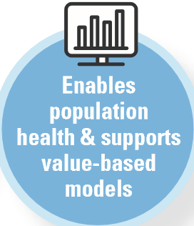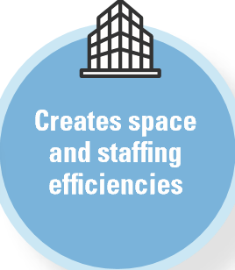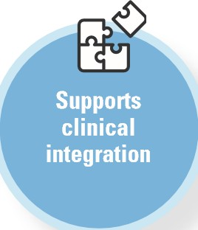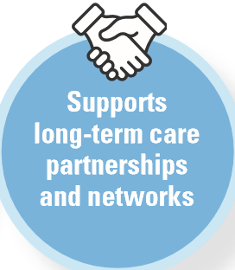

Source: Manatt, 2019
- ..

- . LEARN MORE I Visit AHA.org/center

An integrated system of care with telehealth and other virtual services supports consumer-directed care and value-based models. Digital health and telehealth provide technology infrastructure for population-health initiatives. An enterprise approach to virtual care

enables more efficient operations, creates staffing efficiencies and specialist capacity, improves access and convenience for patients and lowers the cost of care - affordable, high-quality care in the right place, at the right time for the right patient.

The Growth of Telehealth in U.S. Hospitals and Health Systems

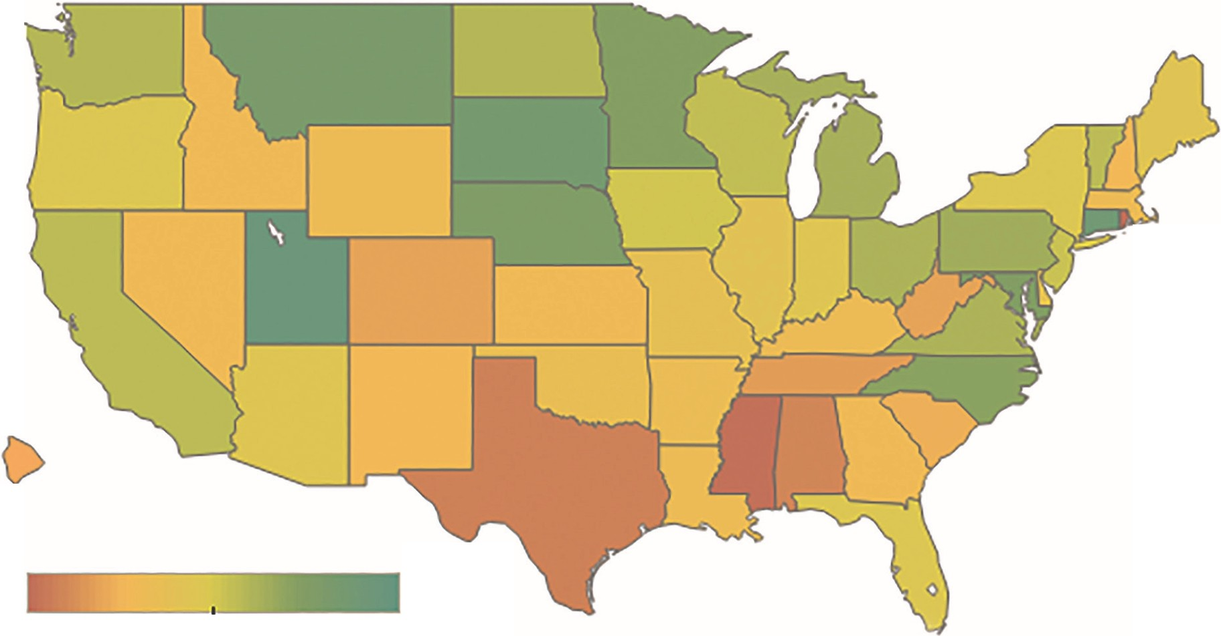-·

0 -..

14% 88%

To advance the adoption, sustainability and optimization of telehealth services, a maturity model is useful to set criteria for competency, capability and level of sophistication. The Hospital Telehealth Maturity Model developed by Manatt Health (Page 8) provides a framework that can be used to measure and develop existing and prospective tele­ health services by program and platform within prescribed best-prac­ tice parameters. This model may be useful for self-assessment and benchmarking to guide telehealth programs toward the adoption of

U.S. Community Hospitals Offering Telehealth Consultation and Office Visits*

*This map illustrates the percent­ age of hospitals in each state that are using telehealth to provide either provider-to-provider or con­ sumer-to-provider consultation and office visits .
Source: AHA Annual Survey, 2017

best practices. In this report, the Hospital Telehealth Maturity Model will be applied to current hospital data on telehealth adoption and uses.

Hospitals and health systems use telehealth in different ways to address patient needs and organizational strategies . Using 2017 AHA Annual Survey data on the adoption and use of telehealth, the AHA Center for Health Innovation has prepared peer comparison data for community hospitals, health systems, academic medical centers, urban hospitals,
- ..
- . LEARN MORE I Visit AHA.org/center

rural hospitals and critical access hospitals. Criteria from the Hospital Telehealth Maturity Model, expert panel interviews and research are applied to hospital cohorts as a framework for the development of

Hospital Telehealth Maturity Model
additional telehealth services. For each type of health care organization, we offer steps to consider and opportunities for expansion of services and partnerships to improve access to timely care.

Basic Foundational Advanced

Telehealth platforms/ technology

Resources

Leadership and governance

Adoption
- Small set of pilot projects
- Rely on fragmented technology solutions
- Limited integration with EHR
- Inefficient workflows
- Unreliable technology

- Limited resource commitment ( <$1M/year )
- No or limited centralized telehealth team or support model; programs individually managed by pilot leaders

- No clear governance structure
- Majority of programs have grown organically and are being directed locally
- Lack of unified vision and strategy
- No or limited success criteria or value metrics
- Poor program visibility across the organization
- No consistent policies and standards

- Moderate levels of adoption among small subset of interested providers
- Established technology platform standards
- High levels of adoption in narrow domains
- Mostly integrated with EHR
- Increasingly efficient workflows
- Good reliability

- Moderate resource commitment ( $1M-$ 5M/year)
- Centralized team that provides limited support for core services (technology rollout and general support)

- Enterprise-level governance structure
that helps to allocate resources and guide decision-making around policies, platform decisions and resource allocations
- Emerging vision and strategy
- Alignment of enterprise priorities and tele­ health investments
- Improving communication and visibility
- Established success criteria and process for measuring and tracking
- Formalized telehealth policies and standards

- High level of adoption within narrow domains
  - Scaled platforms that enable capabilities across the enterprise
  - High levels of adoption
  - Fully integrated with EHR
  - Highly reliable and easy to access

  - Significant resource commitment ( $5M+/year)
  - Robust centralized team with extensive telehealth experience that provides full range of support services (customized design and implementation, training, 24/7 support. optimization, etc.)

  - Fully transparent. highly nimble gover­ nance structure
  - Resources allocated to highest value initiatives
  - Value tracked, measured and used to inform investment decisions
  - Program accountability managed across technology and operations leadership
  - Telehealth policies and standards de­ ployed consistently across the institution

  - High level of adoption across all domains

---'
    - . LEARN MORE I Visit AHA.org/center

Community Hospitals
76°/o
have a
computerized telehealth system
89°/o
have a
computerized telehealth system
Health Systems

Telehealth-use cases
Consultation and office visits

45%
Telehealth-use cases
Consultation and office visits

66%

Stroke care I
Stroke care I

el CU
21%
Psychiatric and addiction treatment
29%
47%
c

l
t:
":r': "'
I

el CU
36%
Psychiatric and addiction treatment

53%
70%
c

l
t:
":r': "'
>

if>

Remote-patient monitoring for ongoing chronic care management
22%
Remote-patient monitoring post-discharge
19%
lo% 1 5 ho h5 120 125 l3o 1 35 140 1 45 l5o 155 l6o 1 65

l7o

":r': "'
0
N
iri
j
Remote-patient monitoring for ongoing chronic care management
48%
Remote-patient monitoring post-discharge
45%
l o% 15 ho h5 120 125 l3o 1 35 l4o 1 45 l5o 155 l6o 1 65

l7o

":r': "'
0
N
iri

j

80°/o
Emergency vir­ tual visits wind up "resolving the episode of care" without a trip to the emergency department (ED) or another site of care.
Source: Jefferson
Health
Community hospitals are moving from the basic to the foundational level on the Hospital Telehealth Maturity Model with opportunities to address gaps in care.

Maturity Model Indicators
- Relying on fragmented technology solutions and limited integra­ tion with the EHR.
- Limited resources and telehealth support model.
- Lack telehealth strategy and governance to set priorities .

Steps to Consider
- Define patient needs that could be met better with telehealth.
- Evaluate partnerships that can address those needs if capabilities are not in house and partner with a network or established tele­ health program.
- Improve reliability and integration with the EHR for efficient workflows .

Opportunities
- Increase specialist access, availability and capacity.
- Reduce rehospitalizations with remote-patient monitoring in target patient populations.
- Add telepsychiatry to care settings with partnerships. •
Many health systems are moving from the foundational to the advanced level on the Hospital Telehealth Maturity Model with opportunities to gain further efficiencies by scaling opportunities across the enterprise.

Maturity Model Indicators
  - Highly reliable platforms integrated with the EH R .
  - Centralized governance, team and significant resource commitment.
  - Resources allocated to highest value initiatives.

Steps to Consider
  - Align digital health teams for capacity management, care coordination and patient engagement.
  - Develop on-demand care teams for different levels of care across the continuum.
  - Continue to evaluate friction points in patient experience and new uses of telehealth to remove.

Opportunities
  - Fully integrate virtual care into health care delivery across the continuum.
  - Use artificial intelligence (Al) to analyze data and navigate patients to the right care.
  - Offer telehealth platform and services to other hospitals.
..

-
    - . LEARN MORE I Visit AHA.org/center

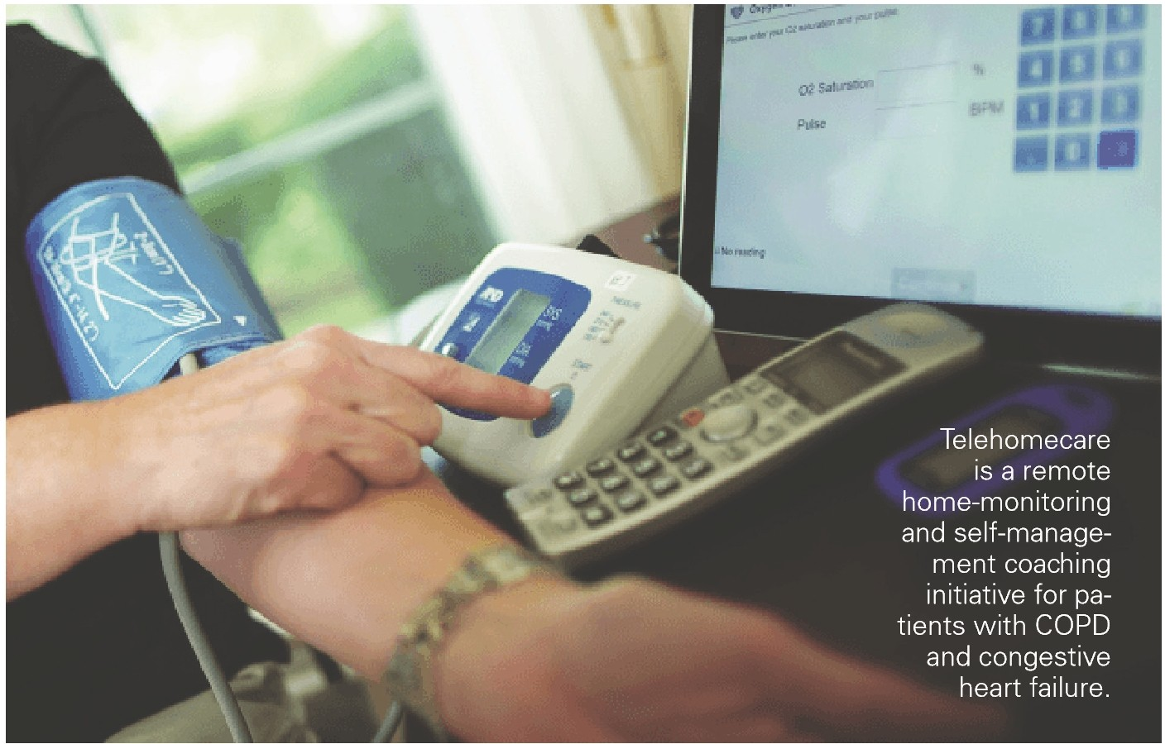Academic Medical Centers

Telehealth-use cases
Consultation and office visits

61%
91 °/o
have a
computerized telehealth system

Stroke care
f
V>
55% c

elCU

21%

V>
t:
I"'

Psychiatric and addiction treatment "'
42%
V>
Remote-patient monitoring for ongoing chronic care management

Health System Case Study: Telehomecare Monitoring
36%
Remote-patient monitoring post-discharge
33%
I"'
"'
0
N

j

Services I Northern Light Health VNA Home Health Hospice I South Portland, Maine
l o% 1 5 ho 115 120 125 l3o 1 35 l4o 1 45 l5o 155 l6o 1 65

Academic medical centers are moving from foundational to the ad­
170

Maine is a predominantly rural state, meaning the distance between patients and medical services can be challenging . For older individuals with multiple chronic conditions, this challenge can be especially prob­ lematic, as consistent monitoring is critical to managing their health.
To address this issue, in 2006 as Northern Light Health, formerly Eastern Maine Healthcare Systems, was merging home care, VNA launched a telehealth monitoring program for a small number of pa­ tients with chronic heart and lung diseases . (See the full case study.)

When VNA launched the telehealth monitoring program, 32 patients in the southern portion of the state were enrolled in an effort to de­ crease heart-failure rehospitalizations. Today, more than 400 patients participate in the program.

"We look at this more as a hospital-avoidance program. Our goal is to connect with patients who have multiple, high-risk diagnoses because that is where we have the most opportunities to intervene and keep them out of the hospital." -Leigh Ann Howard, R.N.. MSN, CHFN-K, di­ rector of home health and specialty services, VNA Home Health Hospice •
vanced level on the Hospital Telehealth Maturity Model with opportuni­ ties to use resources more efficiently and leverage their deep expertise.

Maturity Model Indicators
- High level of adoption within narrow domains, mostly integrated with EHR.
- Centralized team for core services resources and telehealth support model.
- Emerging vision, telehealth strategy and governance to set priorities for highest-value initiatives .

Steps to Consider
- Identify patient populations whose needs could be met with tele­ health, i.e., post-hospitalization services to improve outcomes, chronic care management and geriatrics.
- Structure community-hospital partnerships to provide telestroke, tele­ ICU, telepsychiatry and other specialty services.
- Develop virtual care strategies to efficiently use multidisciplinary care teams and personalized care pathways.

..
- . ,
·••.. LEARN MORE I Visit AHA.org/center

Opportunities
  - Extend specialty and subspecialty expertise and resources to other providers with a telehealth network and offer specialty virtual visits.
  - Employ digital health to improve care coordination, patient engage­ ment and ongoing health management.
  - Combine telehealth with advanced analytics and Al to offer person­ alized medicine services.

Academic Medical Center Case Study: Telestroke Program

Urban Hospitals

Telehealth-use cases
77°/o
have a
computerized telehealth system
Consultation and office visits
26%
Stroke care I

I Mount Sinai Health System I New York City
Mount Sinai Health System -which includes seven hospital cam­ puses in the New York City metropolitan area - has used telestroke

elCU

13%
31%
c

l
t:
I"'

technology to maximize accurate diagnoses and early intervention.
To answer the growing demand for stroke care within its community, the ED at Mount Sinai Queens implemented videoconferencing to consult in real time with a stroke-team specialist at Mount Sinai Hos­
Psychiatric and addiction treatment "'
17% I
Remote-patient monitoring for ongoing chronic care management

pital in Manhattan. Using a state-of-the-art video telecommunications system, the off-site expert conducts a standard stroke evaluation, helps to diagnose the patient and determines if immediate interven­ tion is needed. (See the full case study.)
12%
Remote-patient monitoring post-discharge
10%
I"'
"'
0
N
iri
j

"Through our telestroke program, we can now triage for the endo­ vascular clot-retrieval interventions that have become so important in the past few years." -Stanley Tuhrim, M.D., director, Mount Sinai Stroke Center •

l o% 15 ho h5 120 125 l3o 1 35 l4o 1 45 l5o 155 l6o 1 65
Urban hospitals are moving from the basic to the foundational level on the Hospital Telehealth Maturity Model with opportunities to ad­ dress gaps in care and care coordination across the continuum.
110

Maturity Model Indicators
- Relying on fragmented technology solutions and limited integration with the EHR.
- Limited resources and telehealth-support model.
- Lack unified, formalized telehealth strategy and governance to set priorities.

Steps to Consider
- Define patient needs and inpatient-service shortages that could be met with telehealth.
- Evaluate partnerships that can address those needs and partner with a network or established telehealth program.
- Improve reliability and integration with the EH R for efficient workflows.

Opportunities
- Address specialist and subspecialist shortages in departments with telehealth programs and consider using intensivists via tele-ICU to
improve outcomes .
- ..
  - . LEARN MORE I Visit AHA.org/center

- Reduce readmissions and hospitalizations with remote-patient monitor­ ing and chronic care management in target patient populations.
- Add telepsychiatry to care settings with partnerships.

Urban Hospital Case Study: TeleTriage Emergency Department Program I MedStar Washington Hospital Center I Washington, D. C.
Rural Hospitals

Telehealth-use cases
Consultation and office visits

25%
78°/o
have a
computerized telehealth system

In the TeleTriage model, a triage nurse interviews the ED patient, then
Stroke care I

connects to the off-site attending physician and summarizes the patient's
symptoms . The physician is located in a remote command center with two computer screens. One screen displays a secure, live, two-way vid­ eo and audio connection . The second screen displays the EHR, allowing
the on-duty physician to review medical records that inform the diagnos­

elCU

11%
23%
c

l
t=
":r':

tic pathway and treatment plan, to place patient orders and to document the encounter. ( See the full case study.)
Psychiatric and addiction treatment
11%
Remote-patient monitoring for ongoing chronic care management
10%
Remote-patient monitoring post-discharge
4%

Most rural hospitals are at the basic level on the Hospital Telehealth Maturity Model with opportunities to address gaps in care.

1 10
""0'
N
I
;j'
":r':

"'
"
fl

•
j

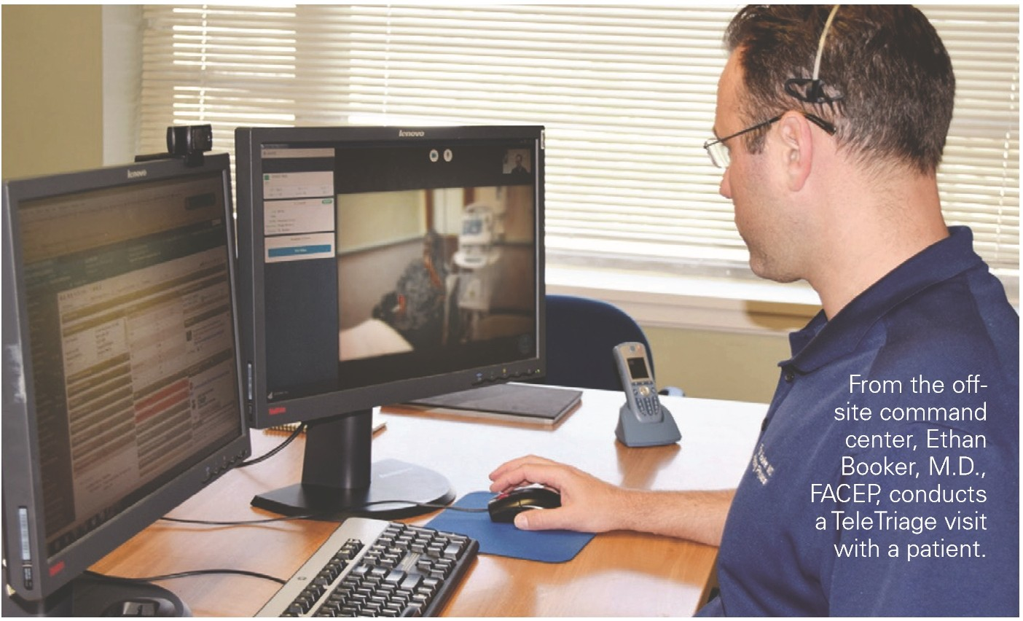Maturity Model Indicators
  - Relying on fragmented technology solutions and limited integration with the EHR .
  - Limited resources and telehealth-support model.
  - Lack telehealth strategy and governance to set priorities.

'After listening to the triage nurse's presentation, reviewing the pa­ tient's histor y and speaking to the patient, the physician then makes a preliminar y diagnosis and immediately places orders into the system. Instead of returning to the waiting room, the patient then moves to the internal area of the ED for initial diagnostic treatment." -Ethan Booker,
M.D.. FACEP, attending physician in the department of emergency medicine at MedStar Washington Hospital Center and medical director of the MedStar TeleHealth Innovation Center at Ml2. •
Steps to Consider
- Define patient needs that could be met better with telehealth .
- Evaluate partnerships that can address those needs and partner with a network or established telehealth program.
- Improve reliability and integration with the EHR for efficient workflows.

Opportunities
- Offer comprehensive OB-GYN care and other specialist access through virtual visits.
- Use telestroke and tele-ICU to minimize patient transfers and provide advanced care locally.
- Add telepsychiatry to address the opioid epidemic and to care set­
tings with partnerships .

- ..
- . LEARN MORE I Visit AHA.org/center

Rural Hospital Case Study: Virtual Urgent Care I
Bryan Health I Lincoln, Neb.
Bryan Health, a Nebraska-governed, nonprofit health system in Lincoln, launched Bryan Health ezVisit as a strategic effort to expand access to care. Bryan Health ezVisit is a simple-to-use, online diag­ nosis and treatment option for minor health conditions. Offered at
an inexpensive flat-rate fee, Bryan Health ezVisit makes mainstream medicine not only affordable, but also easily accessible to anyone with a smartphone, computer or tablet. (See the full case study.)

"{ezVisit} allows smaller hospitals to provide virtual urgent care at

Telehealth-use cases
Critical Access Hospitals
Consultation and office visits

Stroke care

el CU
15%

36%

47%
72°/o
have a
computerized telehealth system

I
c

l
t:
I"'

an inexpensive price point. This provides rural communities access to cutting-edge technology care they wouldn't otherwise be able to afford." -Andy Whitney, director, Bryan Telemedicine Services •
Psychiatric and addiction treatment "'
23% I
Remote-patient monitoring for ongoing chronic care management

15%
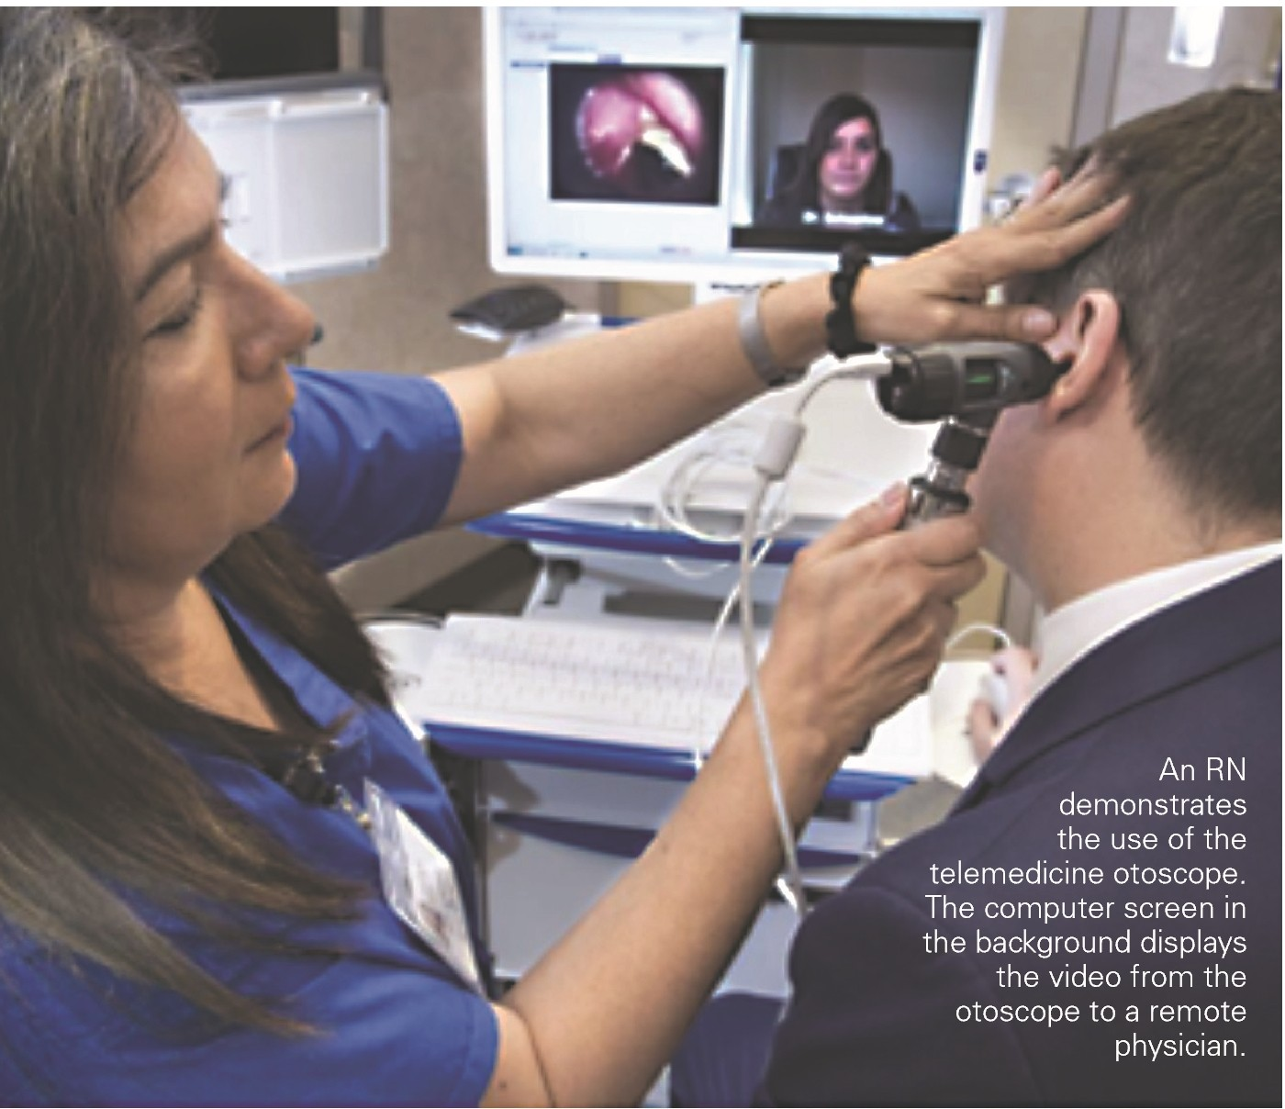Remote-patient monitoring post-discharge
9%
I"'
"'
0
N
iri

j
110

Most critical access hospitals are at the basic level on the Hospital Telehealth Maturity Model with opportunities to address gaps in care and expand the provider network.

Maturity Model Indicators
  - Relying on fragmented technology solutions and limited integra­ tion with the EHR.
  - Limited resources and telehealth-support model.
  - Lack telehealth strategy and governance to set priorities.

Steps to Consider
  - Define patient needs that could be met better with telehealth .
  - Evaluate partnerships that can address those needs and partner with a network or established telehealth program.
  - Improve reliability and integration with the EHR for efficient work­ flows.

Opportunities
  - Expand specialist access and provide comprehensive OB-GYN care through telehealth programs.
  - Use telestroke and tele-ICU to minimize patient transfers and
provide advanced care locally.
- ..
    - . LEARN MORE I Visit AHA.org/center

- Grow telepsychiatry to address the opioid epidemic and to care set­ tings with partnerships.
Critical Access Case Study: Telepsychiatr y Program I
PeaceHealth Peace Island Medical Center I Friday Harbor, Wash.
Situated on San Juan Island, PeaceHealth Peace Island Medical Center is a 10-bed critical access hospital with primary care and specialty clin­ ics, a cancer center and a 24-hour emergency department (ED).
After conducting a community-needs assessment in 2014, leaders at PeaceHealth Peace Island were compelled to develop an integrated behavioral health program in collaboration with primary health care pro­ viders on San Juan Island. Before this, no psychiatrists practiced on the island. Given the challenging location of the medical center, a telepsy­ chiatry approach offered the most promise. ( See the full case study.)

"Partnering with a psychiatr y department that has a deep bench has been very important in terms of ensuring that providers are available to our patients." -Merry-Ann Keane, MSN, BSN, NE-BC, FACHE, chief adminis­ trative officer, PeaceHealth Peace Island Medical Center •

How Hospitals and Health Systems Can Build Their Telehealth Capacity
Which telehealth technology a hospital or health system buys and from whom they buy it depends largely on where they are on their virtual care journey, commonly referred to as their telehealth maturity. Borrowing that descriptor of the spectrum, are hospitals and health systems telehealth newborns, toddlers, tweens, teens, young adults or adult adults?

Experts agree that now, few hospitals and health systems are adult adults when it comes to telehealth . That means only a few have created enterprisewide virtual care systems that mirror every aspect of their
clinical and financial operations along the entire continuum of care.

Experts also say that most hospitals and health systems are telehealth newborns and toddlers . That means they've dabbled in a few disparate telehealth technologies at the urging of an enthralled tech-savvy doctor or because grant money funded the purchase and implementation of the technologies at no cost to the hospital or health system.

The rest of the hospitals and health systems swimming in the telehealth pool are somewhere in the tween, teen or young-adult phases, stretching their telehealth wings across more departments and more functions.

So, how do hospitals and health systems mature along that spectrum? As with all positive change in health care, it starts with culture, and culture starts at the top. The governing board and C-suite at a hospital or health system can ignite that cultural change with a telehealth vision statement that recognizes, accepts and embraces virtual care as an extension of what everyone at the hospital or health system does. It's not something new or separate or different. It's not telehealth care. It's simply health care.

In fact, adult-level hospitals and health systems prefer to call it virtual care to focus on the experience rather than telehealth, a term that many people associate with technology. Physicians and patients are more accepting of virtual care as another form of care than they are of new technologies. Suc­ ceeding at telehealth is as much of a change in mindset as it is a change in technology and vendors.

Scaling and Optimizing Telehealth Programs

No matter where a hospital or health system is along that telehealth program maturity spectrum, the goal is the same: Optimize the value of the program so it continues to grow. But like any new strategic initiative, it may not take much to knock a program off course, killing it before it has a chance to scale.

Other cultural attributes that speed the telehealth maturation process at hospitals and health systems

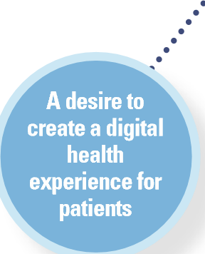A fearlessness to disruptthe status quo
Letting community need and physician usability, not ROI, drive telehealth
decisions
An understanding and appreciation of the growing tech savvy of patients
Challenging the notion that patients always need to be seen physically for
care

Seeing telehealth's possibilities as endless

.,,.
A willingness to push the
envelope on what telehealth
can do
..,
·•• ' LEARN MORE I Visit AHA.org/center
_

What are the secrets to optimizing a hospital or health system's telehealth program? How do hospitals and health systems convert their telehealth vision statements into strategies and tactics that make their telehealth programs invaluable to physicians, patients and other stakeholders?
Expert Panel

The AHA Center for Health Innovation thanks the following people, organizations and sources for the time and insights that made this Market Insights report possible:
Jared
Augenstein
Senior manager. Manatt Health
Grant
Chamberlain Managing director. corporate finance health care practice.
Ziegler
Benjamin K.
Chu, M.D.
Managing
director. Manatt Health
Todd
Czartoski, M.D. Chief medical technology officer. Providence
St Joseph Health
Kristi
Henderson Vice president. patient access and health care transformation.
Ascension
Jessica
Duke Telehealth manager.
Huron
Deanna
Larson
CEO.
Avera eCAR
Shane
McGuire CEO. Columbia County (Wash I
Hea Ith System
Bharat
Sutariya, M.D.
Vice president and chief medical officer.
Cerner Corp.
Chantal
Worzala
Vice president. health information technology and policy operations .
AHA

As mentioned, the two essential elements of a successful telehealth pro­ gram are integration into the EH R system and integration into the work­ flow of clinicians. Optimization, though, goes beyond those two telehealth table stakes. The other essential elements to successful optimization include:

  - Using community and patient need as the starting points for the consideration of new telehealth services. Many telehealth services go fallow because they started with interest by a physician or the finance office. Serve patients first, and physicians and reimbursement will follow.

  - Using telehealth services to coordinate care across health care set­ tings. One of the best uses of telehealth technology is tracking the health status of patients after discharge . Monitoring their health at home or in post-acute care settings can lead to better outcomes and lower costs.

  - 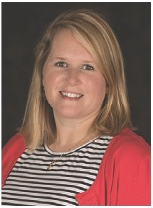Incorporating telehealth services into value-based care. Telehealth services are an effective way to drive down the cost of care, making them valuable tools to use in value-based reimbursement models that reward hospitals and health systems for lower utilization costs .

  - Using telehealth services to help direct patients to the appropriate level of care. Enabling a patient to talk virtually with a doctor can help to determine whether he or she should go to the pharmacy for a deconges­ tant, schedule an office visit with his or her doctor or go immediately to the hospital ED.

  - 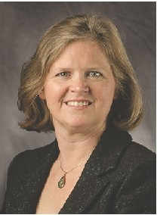Setting key performance indicators (KPls) for telehealth. Hospitals and health systems must have analytics capabilities to track and report how each of their telehealth services is performing against KPls for that service . That could be general telehealth utilization, experience and satis­ faction by doctors and patients, or it could be specific clinical outcomes like readmissions, elapsed sepsis diagnosis time and elapsed stroke diag­ nosis and treatment time.

Successful hospital and health system telehealth programs don't happen by accident. It requires discerning technology choices and critical vendor selection, it demands uncomfortable cultural changes and the right execu­ tion to create a comprehensive virtual care delivery system for patients. •
- ..
    - . LEARN MORE I Visit AHA.org/center

Reports, Surveys, Articles and Research
- 2017 AHA Annual Survey Informat ion Technology Supplement Database. Chicago : American Hospital Assocation, www.ahadata .com

- "2018 Funding Part 2: Seven more takeaways from digital health's $8.1 B year:· Rock Health. https://rockhealth.com/reports/seven-more-takeaways-from-digital­ healths-8-1 b-year/

- "Beyond the EHR : Shifting payment models call for hospital investment in new technology areas ." Deloitte Center for Health Solutions. https://www2.deloitte.com/ insights/us/en/industry/health-ca re/health-information-tech nology.htmI

- "Deconstructing the Telehealth Industry: Part 11 : Improving the Access Points of Healthcare Delivery." Ziegler. https://www.ziegler.com/newsroom/2018/04/decon­ structing-the-telehealth-industry-part-ii-improving-the-access-points-of-healthcare-delivery/

- FY 2017 AHA Annual Survey Database. Chicago: American Hospital Association, www.ahadata.com

- "Healthcare Disruption: The Future of the Healthcare Market:' Reaction Data. https://www.reactiondata.com/report/healthcare-disruption/

- "Jefferson Health Goes 'All In' on Telehealth." Health Forum. http://www.healthforum.com/connect/resources/pdf-files/teladoc-2018-0511-cs-jefferson.pdf

- "Patient and Clinician Experiences with Tele health for Patient Follow-up Care." American Journal of Managed Care. https://www.ajmc .com/journals/is­ sue/2019/2019-vol25-n1 /patient-and-cl inician-experiences-with-te lehealth-for-patient-fol lowup-ca re

- "The Use OfTelemedicine By Physicians: Still The Exception Rather Than The Rule." Health Affairs. https://www.healthaffairs.org/doi/abs/10.1377/hlthaff.2018.05077

- "Top of Mind for Top Health Systems 2019: Insights from health systems on IT priorities for the year ahead:' Center for Connected Medicine and The Health Man­ agement Academy. https://www.connectedmed.com/blog/content/top-of-mind-2019-interoperability-cybersecurity-telehealth

- "Trends in Telemedicine Use in a Large Commercially Insured Population, 2005-2017." Journal of the American Medical Association. https://jamanetwork.com/jour­ nals/jama/article-abstract/271654 7

- "VERITAS shows virtual assistant with clinical oversight as effective as traditional physical therapy ." Duke Clinical Research Institute. https://dcri.org/veritas-results/

- "What can health systems do to encourage physicians to embrace virtual care?" Deloitte 2018 Survey of U.S. Physicians. Deloitte Center for Health Solutions. https://www2. deloitte.com/insights/us/en/industry/health-ca re/virtua1-hea Ith-care-health-consume r-and-physicia n-surveys. htmI

  - iNNO'VAtiON I

INSIGHTS

Contact Lindsey Dunn Burgstahler at 312-893-6836 for more info I www.AHA.org/center
MARKET

